LINK: <https://openweathermap.org/api>

**GET REQUEST**

Key: &APPID=c41f8ad5489f1b0a290744ea124aeaf8

Link: <https://samples.openweathermap.org/data/2.5/weather?q=Kharkiv>,UA

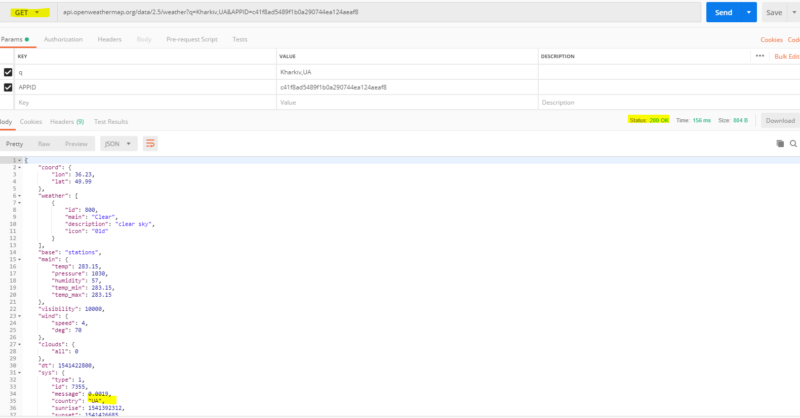

**POST REQUEST** 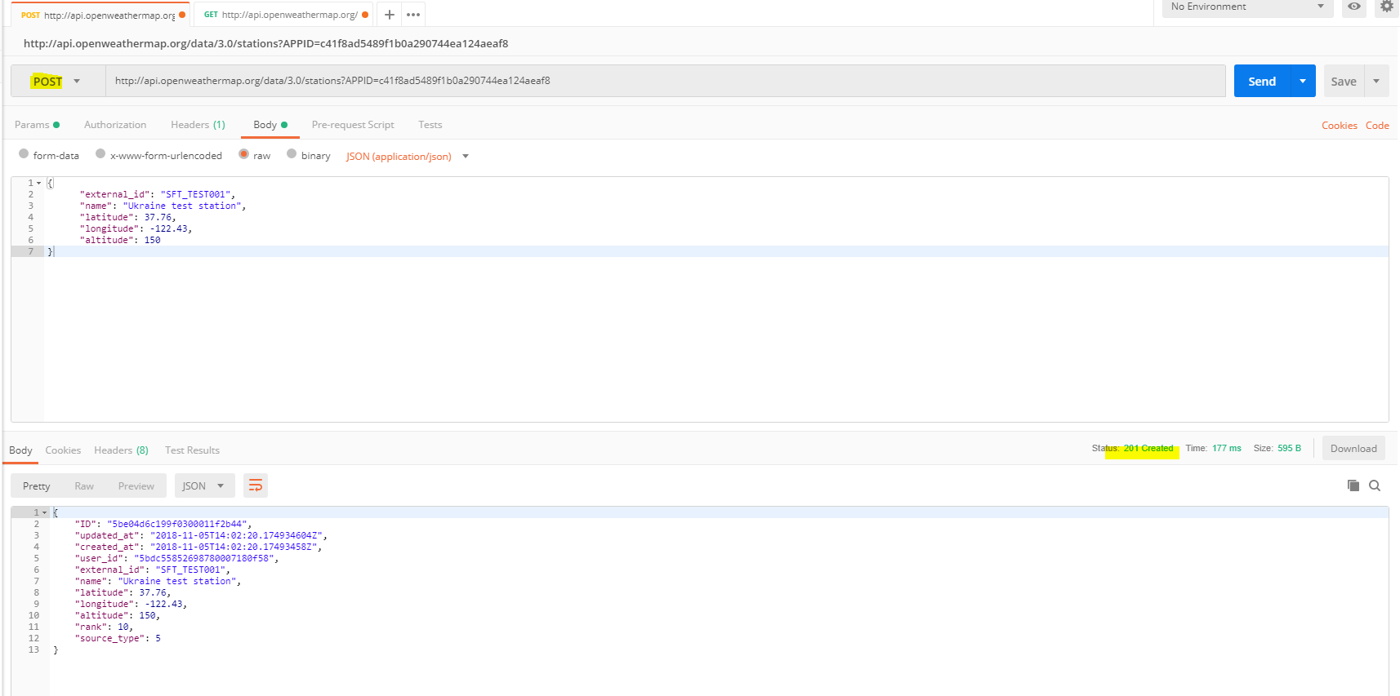

**PUT REQUEST**

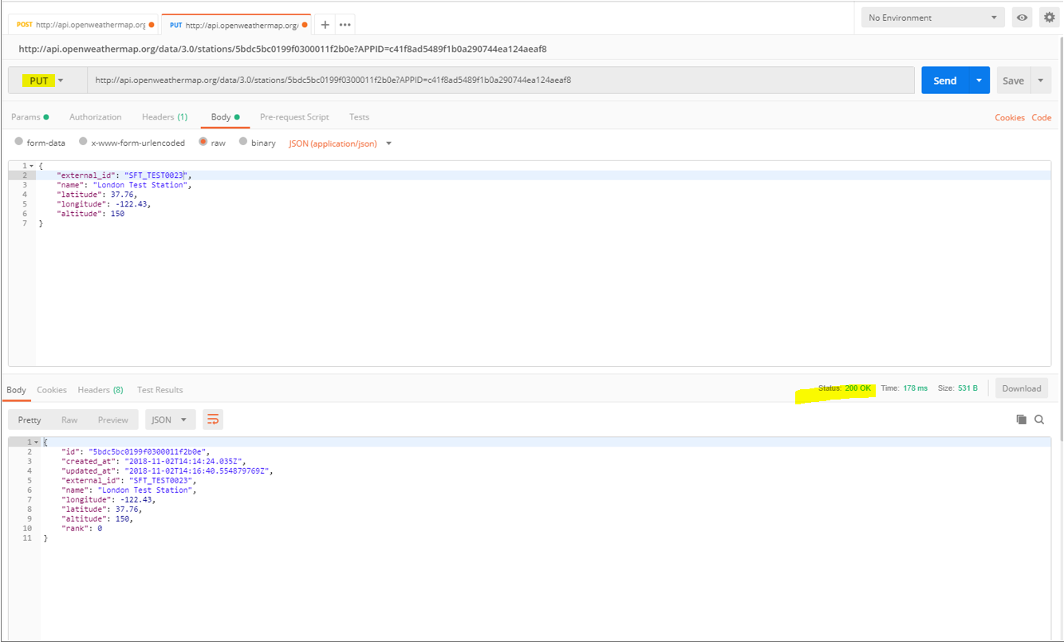

**DELETE REQUEST**

